**Prokaryotic Showdown**

**Interim Report**

**The Game, the Vision**

* Players are taken into a world which cannot be seen by the naked eye and are given the power to control microscopic organisms – the bacteria.
* Our game will capture the microscopic world like never before with cool animations and a rich environment.
* Players must explore the world with their bacterial units and find resources which will help them survive and strengthen their attack or defense against other players.
* The world is filled with resources like food and water but will also have threats in the form of viruses and anti-bacterial drugs.

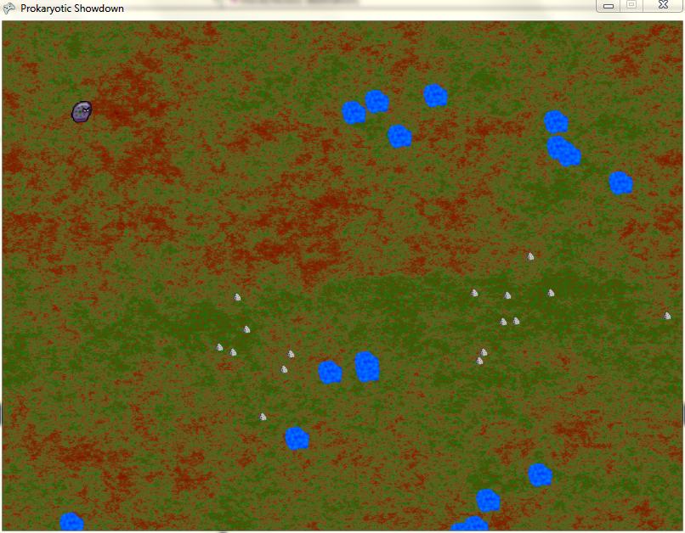

*Fig. 1: The World containing a bacterium and some food and water.*

* Players will have a limited number of resources points which they will use to perform various actions like moving, growing, spawning, attacking etc.
* Players will use a mouse and keyboard to play the game. Following are some of the actions they can perform:
  + Use mouse to select and deselect units.
  + Move the units around in the world using mouse clicks, find and collect resources.
  + The game will have a top view and the players will control the camera with either their mouse or keyboard to determine which part of the world they can see.
  + Use keyboard to spawn and grow the bacteria.

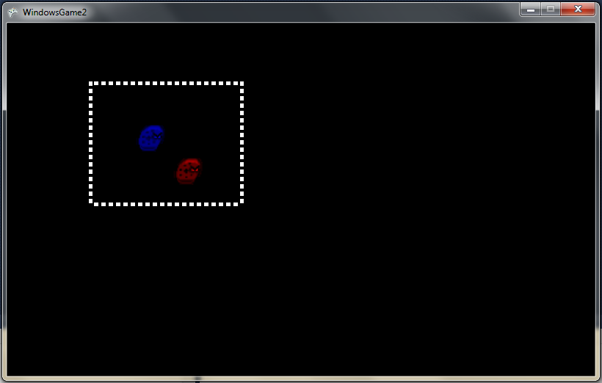

*Fig 2. Selection, movement, and deselection of bacterial units.*

**The Menu**

* The game will have a simple menu system with the following options:
  + New Game
  + Difficulty level
  + Instructions
  + Resolution
    - Toggle Full Screen
  + Exit Game

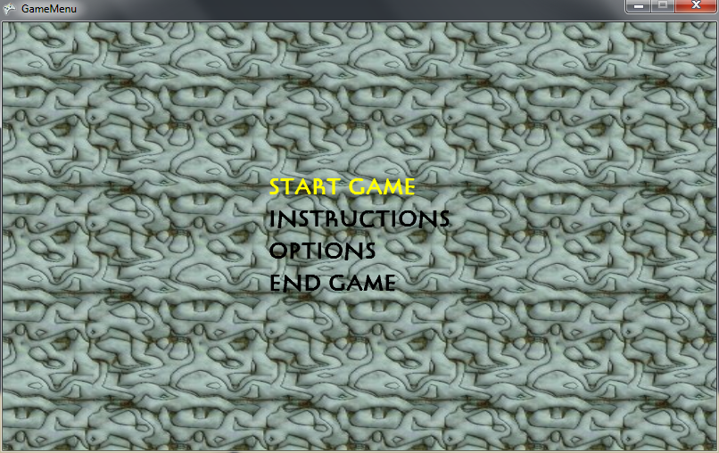

**The HUD**

* The Heads-up display will show the following information.
  + Resource points
  + Bacteria Population
  + A Mini-map
  + Health of the bacteria
  + Score

**Artificial Intelligence**

* The game will use a path finding algorithm to move the bacterial units from one point to another avoiding obstacles in their path.
* Also, the bacteria will detect nearby enemies and start attacking if the enemy is within their radius of perception.

**Networking**

* Enabling multiplayer over a network or the internet will be appropriate for an RTS game which is our high target/extra and will be worked upon after the desired target is achieved.

**Sound**

* Adding sound is relatively simple as compared to other tasks and will be one of the last things to be implemented.

**Layers**

* **Functional Minimum**
  + Our functional minimum layer will be a single player survival game where the objective of the game is to survive.
  + The world will consist of resources which the player should collect in order to grow and multiply.
  + Each grow and multiply action will cost some resource points.
  + The world will also consist of threats such as viruses and anti-bacterial drugs. Some threats move about in the world while some are stationary.
  + The bacteria will have health and die if their health reaches zero.
  + Players need to accomplish objectives such as maintaining some amount of resource points for a particular length of time, or grow the population up to a certain level etc. to win the game.
* **Low target**
  + The world map will be a battle ground where 2 players will grow their respective bacteria population and try to exterminate the other population for dominance.
  + Players build up their resources (resource points) and use them for attack and defense.
  + It will be turn-based.
* **Desired Target**
  + The game will have a store where the players will be able to buy upgrades to evolve their bacterium race.
  + Upgrades may include health, resistance to diseases, faster movement etc.
* **High Target**
  + Players can choose among multiple races of bacteria, each having unique abilities.
  + Players can choose among more than one world to play in.
  + The game will have a Fog of War (FOW) which will make the world more mysterious.
  + All the resources and enemies will be hidden on the map and will be revealed as the player explores the world.
  + A larger, interesting world with a lot more variety of resources and threats.
* **Extra**
  + Make the game a real time strategy game instead of turn based.
  + Online Multiplayer.

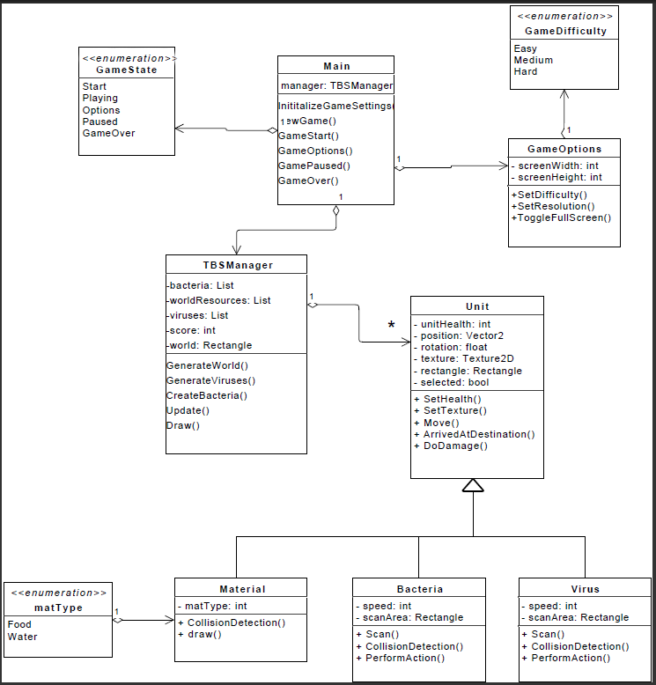

***Fig. 3: Design Specification***

**Implementation**

**The main class**

* Manages game state **(Complete)**
* Also handles the menu system
* It initializes an instance of TBSManager which is responsible for the gameplay (Turn-Based Strategy)

**GameOptions class**

* Adjusts and stores game settings like resolution, full screen, and difficulty

**TBSManager class**

* Responsible for gameplay
* Generates the world **(complete)**
* Contains a list of all world objects **(complete)**
* Handles camera movement
* Handles input
* Updates the state of the objects and draws them to the screen

**Unit class**

* Stores information about all the objects in the game **(complete)**
* Parent class of Virus, Bacteria and Material **(complete)**
* Stores position, health, texture etc. of all the objects in the world **(complete)**
* Handles movement of units
* Units will probably have AI

**Bacteria class**

* Derives from the Unit class **(complete)**
* Stores information specific to the bacteria **(complete)**
* Detects collisions with other objects
* Scans its surrounding and performs an action depending on the type of unit
* If the unit is a material( food or water), it collects it, and if the unit is an enemy, attacks it

**Virus class**

* Derives from the Unit class **(complete)**
* Stores information specific to the Virus **(complete)**
* Detects collisions with other objects
* Simple AI for viruses to automatically attack nearby enemies **(complete)**

**Material class**

* Stores information about the resources in the world **(complete)**
* Can be either food or water **(complete)**

**Responsibilities**

* Abdul Aaquib
  + Team Leader
  + Design Specification
  + Game State Management
  + AI
  + Game Balance
* John Taylor
  + Programmer
  + Player Movement
  + Collision Detection
* Sriram Padavala
  + Programmer
  + Menu System
  + HUD
* Heidi Haack
  + Programmer
  + Camera Movement
  + AI
  + Resource Management
* Mitchell McClish
  + Programmer/Tester
  + Sprite animation
  + Graphics and Audio

**Challenges**

* **Game Mechanic**:

We initially started out to build a turn based strategy game where the bacteria would be at fixed locations and could grow and multiply. The players would only attack each other if their bacteria were adjacent to each other. This game play was rigid and slow and was an exact replica of the board game. Hence, we changed the game mechanic to allow players to move their bacteria around in the world which gave the players (and more importantly us) more freedom to be creative.

* **Design**:

This is the most important part of any software. The stronger the design, better is the product. Hence, we came up with a design that would allow us to modify any part of the game easily, and allow additional features to be added to the game without much difficulty. The design specification is included in this report and we have only included the most important functions in the UML diagram.

* **Collision Detection:**

This is harder than anticipated. Collision between the bacteria and other objects can be easily handled but, as the player has to control many bacteria at the same time, collision detection among the bacteria as well as moving many bacteria from one place to another poses an interesting challenge.

* **Artificial Intelligence:**

This will be our biggest challenge. We need a path finding algorithm to enable the bacteria to find their way around obstacles to the destination. Also, we have implemented a simple AI for the viruses, which enables the viruses to scan nearby regions for bacteria and start attacking them if they are within their scan radius.